PRODUCT IDEA PROPOSAL

Runable Companion
Bringing Runable's AI agent into the user's browser workflow
Prepared by | Sunil Kumar
Role | Software Engineer Intern (New Grad) – Application
Proposal type | Independent idea proposal for the Runable product

Concept in one sentence
A browser extension that lets users access Runable from a side panel, ask questions about selected webpage text, open the panel with a keyboard shortcut, and summarize the current page.

1. Overview
Runable is an AI agent platform designed to help users and small businesses complete day-to-day work across web, mobile, desktop and messaging. It can help create and deploy websites and apps, produce documents and presentations, browse the web and carry out longer-running tasks.
Runable Companion is a product idea for extending access to Runable into the browser. The goal is to let users reach Runable while they are already working on a webpage, rather than repeatedly switching tabs to open the Runable website. The extension would complement Runable's existing product and use its approved agent integration, rather than recreate the agent platform.

2. User difficulties with the current workflow and opportunity
When users research, read documentation, compare information or work through online tasks, they may need to leave the current page to open an AI assistant. They may also have to copy and paste text manually before asking a question. Runable Companion could reduce that friction through four focused capabilities:
- Reduce tab switching: keep the current webpage visible while using Runable.
- Make page content easier to use: send selected text and its source page to Runable in one action.
- Make access faster: open Runable's side panel using a keyboard shortcut.
- Make information easier to understand: summarize the current webpage with one click.
The opportunity is to make Runable available at the moment users encounter information they want to understand or act on.

3. Proposed core features

1) Runable Side Panel
Access the Runable AI agent directly from any webpage without switching tabs. When the user clicks the Runable Companion extension icon, a side panel opens alongside the active webpage. The user can interact with Runable while continuing their current task.

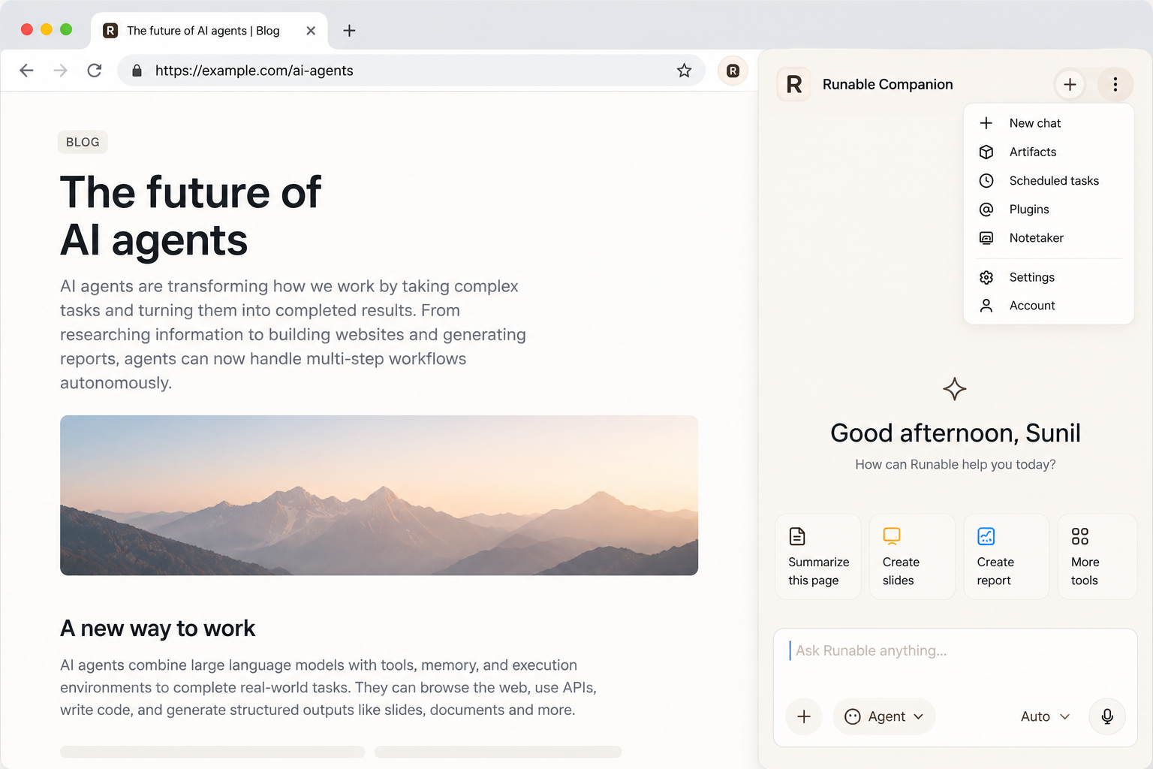

2) Ask with Runable
Select webpage text, right-click, choose the option “Ask with Runable”, and automatically send the selected content to the Runable side panel. The source webpage URL can be included as context so the user does not need to copy and paste the selected text manually.
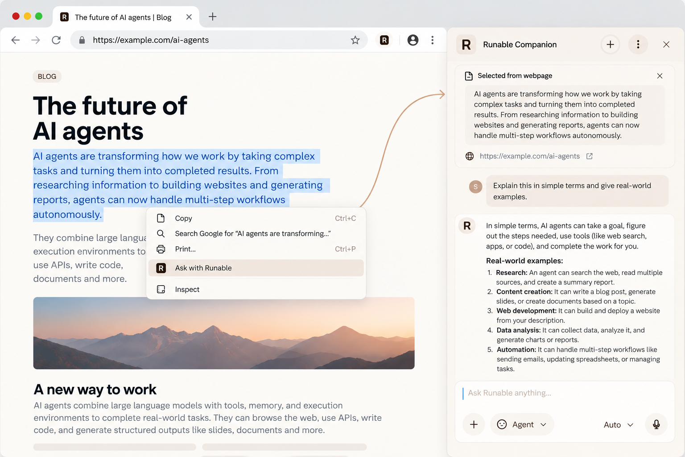

3) Keyboard shortcut to open side panel
Provide a configurable keyboard shortcut that opens the Runable side panel instantly. This gives frequent users a quick alternative to clicking the extension icon. The shortcut should avoid common browser and operating-system conflicts, and users should be able to change it through the browser's extension shortcut settings.

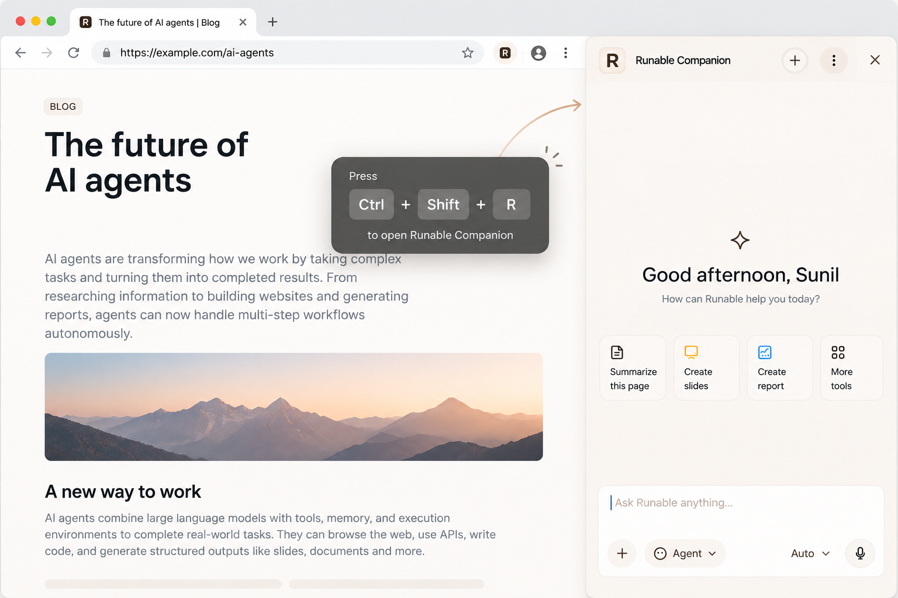

4) Summarize this page
Provide a one-click “Summarize this page” action in the side panel. After the user initiates the action, the extension collects the page content needed for summarization and sends it to Runable through an approved integration. The result appears in the side panel, with the page URL retained as its source and the option to ask follow-up questions.
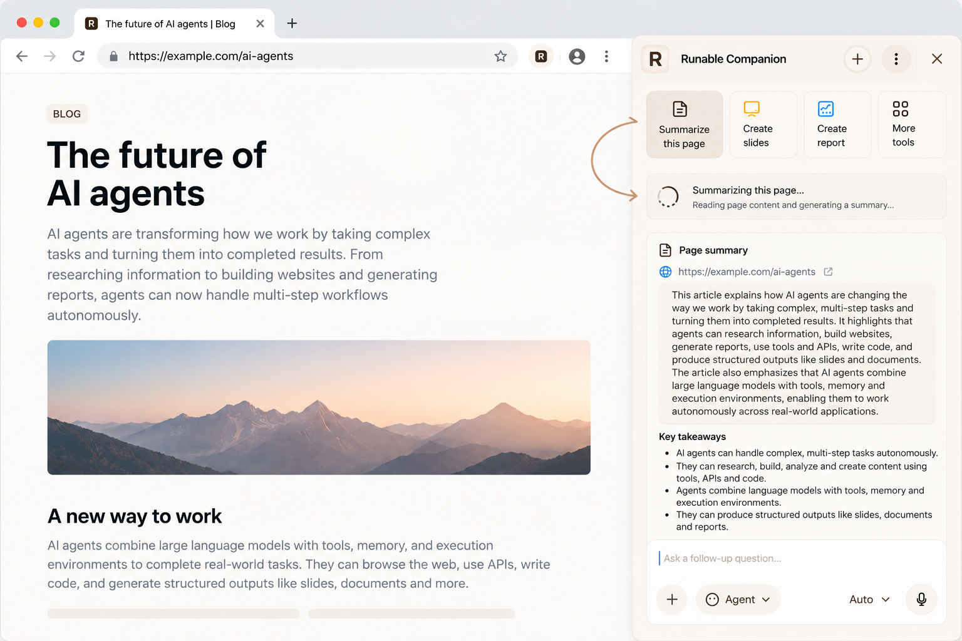

4. Technical approach
A practical implementation could use Chrome Extension Manifest V3 with a React and TypeScript interface. The extension would provide the browser interface, while Runable's existing agent and backend would handle AI processing through an approved API or internal integration.
Area | Possible technology / API | Purpose
Extension framework | Chrome Extension Manifest V3 | Extension lifecycle, permissions and configuration
Side panel | chrome.sidePanel | Display Runable alongside the active webpage
Context menu | chrome.contextMenus | Add “Ask with Runable” for selected text
Keyboard shortcut | chrome.commands | Open the side panel using a configured shortcut
Page content | User-initiated access using suitable permissions / scripting | Pass selected text or page content for the requested action
Frontend | React + TypeScript; Tailwind CSS optional | Build the side-panel interface and interaction states
AI integration | Runable-approved API or internal integration | Authenticate users and send requests to Runable's agent
Integration dependency: the real extension needs an approved Runable authentication and API/integration path. I would not assume that the Runable website can be embedded in an extension panel. A native extension interface connected to supported Runable services may be more suitable. Until internal integration access is available, a prototype can use mock responses to demonstrate the browser experience.

5. Publication considerations
The extension could be distributed through the Chrome Web Store and Microsoft Edge Add-ons. Based on the current publisher-registration information, Chrome requires a one-time US$5 developer registration fee. Microsoft Edge Add-ons developer registration is free. Store policies, eligibility and publishing requirements should be checked again before release.
Store | Developer registration fee | Note
Chrome Web Store | One-time US$5 fee | Developer account registration
Microsoft Edge Add-ons | Free (US$0) | No developer registration fee
These are publisher-account registration costs, not development or maintenance costs. Additional operational costs, if any, would depend on Runable's infrastructure and integration choices.

6. Why I am proposing this — my fit to develop it
I built GitPulse, an AI-powered GitHub analytics browser extension using React, FastAPI, Supabase, GitHub REST API, GitHub Remote MCP, Groq cloud and GPT-OSS 120B. GitPulse provides developer scoring, repository analysis, technology-stack analysis, activity tracking, repository quality assessment and portfolio-readiness insights.
I owned the end-to-end implementation across the extension frontend, FastAPI backend, API and AI integrations, tool orchestration, context handling and deployment. I also worked on secure MCP execution, streaming responses and PDF report generation. GitPulse is publicly available as a Microsoft Edge Add-on.
GitHub repository: https://github.com/sunilkumar1701/GitPulse
Microsoft Edge Add-on: https://microsoftedge.microsoft.com/addons/detail/gitpulse/lepaenbflcpokamnoilhengjcfcafdol
This experience gives me a practical foundation in browser extension development, frontend/backend integration and AI-enabled workflows. I have also solved 240+ LeetCode problems in Java and have experience contributing to production mobile applications, implementing features, debugging issues and integrating REST APIs.
I am proposing Runable Companion because it connects directly with my experience building and publishing GitPulse, while giving me an opportunity to contribute to a product I find interesting. I would be keen to understand Runable's existing architecture and adapt the proposal to the team's priorities and technical constraints.

7. Demo in preparation and follow-up
I am preparing a small demo to illustrate the proposed browser experience, focusing on the side panel, the “Ask with Runable” context-menu workflow, the keyboard shortcut and page summarization. The demo is intended to demonstrate the extension interaction and user journey; connection to Runable's production agent would require an approved integration.
I plan to share the demo and proposal with the Runable team and reach out through LinkedIn as a follow-up to my email. I would welcome feedback on whether this direction fits the product and what a useful first engineering milestone would be.

8. Closing thought
Runable Companion is a focused idea to make Runable easier to access at the exact moment users need help with information on the web. The goal is not to create another standalone AI product, but to bring Runable's existing agent closer to the user's current task through a simple, useful browser experience.

Prepared by Sunil Kumar

